**ACTIVITY 2.1:** **Basic SQL Command – No constraints and Referential Integrity**

**Setting-up Command Prompt**

1. Start your XAMPP control panel and the make sure to hit on START button to Apache and MySQL.

**My XAMPP control panel:**

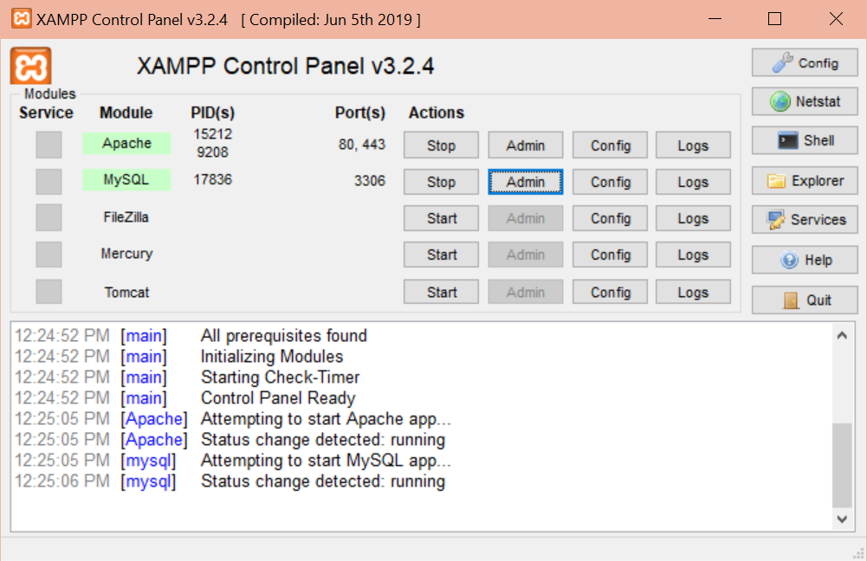

1. On your keyboard, key in  to run command prompt.
2. Type **“cmd”** in the field provided and then click **OK** or hit **‘ENTER’**.
3. You will be shown the command prompt similar to the display below:

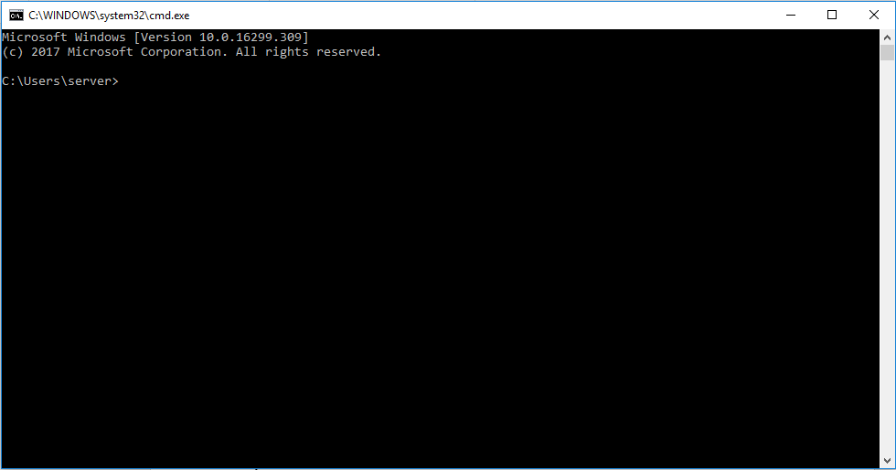

**My command prompt:**

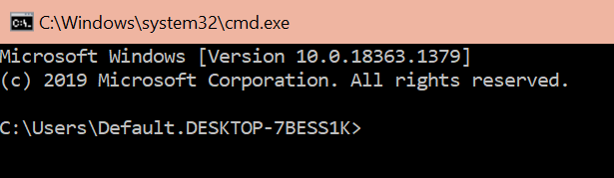

1. By using the command below, it means you’re changing directory to drive **C:\.**

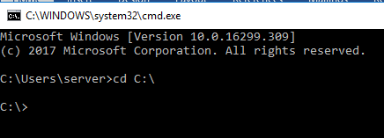

**My command prompt:**

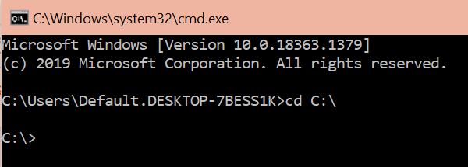

1. Now, invoke the following commands below then hit **ENTER**.

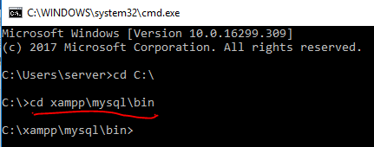

**My command prompt:**

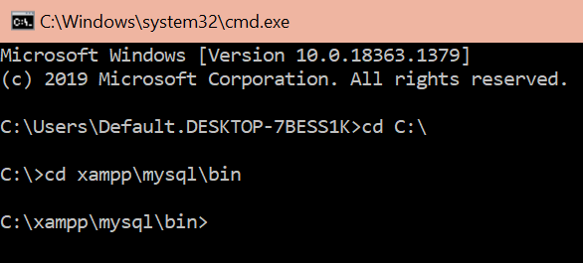

1. See commands underlined in red. Just hit **ENTER** all throughout until you will see this:

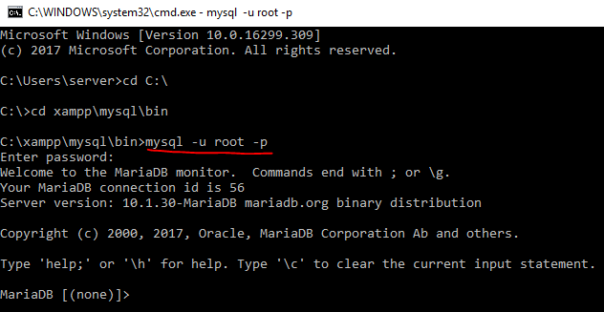

**My command prompt:**

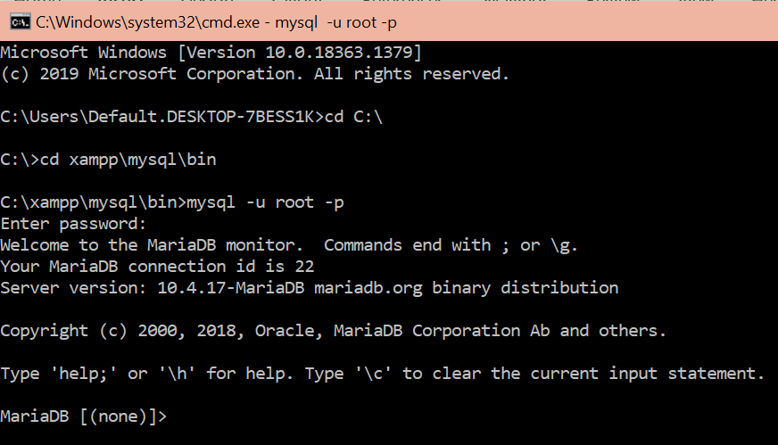

1. Now, you are all set. You can show database files on your localhost by invoking command below:

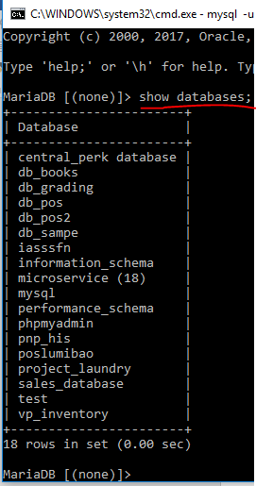

**My command prompt:**

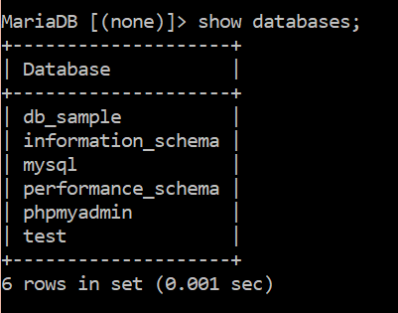

***---------------------- [DDL-Table Structures and Specifications] ----------------------***

1. Create a database with a name following the format **<your last name>_activityBasicSQL**

Example: ***BASTE_ActivityBasicSQL.***



**My command prompt:**

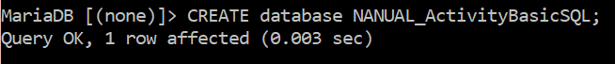

1. To show if a database is created, use the following command: ***SHOW databases;***

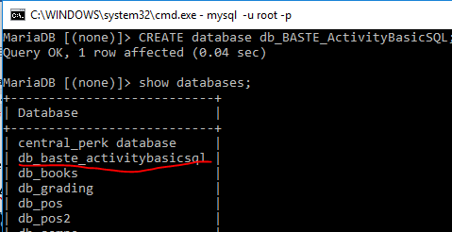

**My command prompt:**

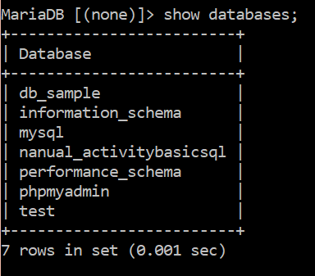

1. Now, every time you want to invoke changes to a certain database like adding tables, changing name of the tables, etc you will need to use the **USE** ***database_name*** command. Below is an example:



**My command prompt:**

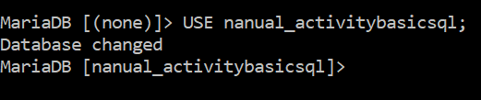

1. Now let’s get started by creating tables on your database.
2. Write a database description (tables) for each of the relation shown below using DDL (Data Definition Language).
3. Create a table **“Pet”.** Your table should have the following fields: Pet_ID, Pet_Name, Pet_Gender, Pet_Color, Pet_Age , Pet_Type.

***Your table should be:***

|  |  |  |  |  |  |
| --- | --- | --- | --- | --- | --- |
| **Pet_ID** | **Pet_Name** | **Pet_Gender** | **Pet_Color** | **Pet_Age** | **Pet_Type** |

**My command prompt:**



1. To show the tables you have created you can use the following statement:

***SHOW tables;***

**My command prompt:**

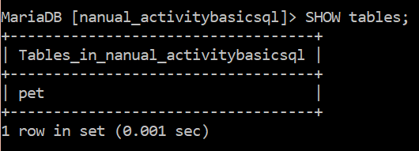

1. If ever you want to look at the **metadata** of a table, you may use either any of the following DDL-SQL statements:

***DESCRIBE tbl_pet;*** *or* ***SHOW FIELDS FROM tbl_pet;***

**My command prompt:**

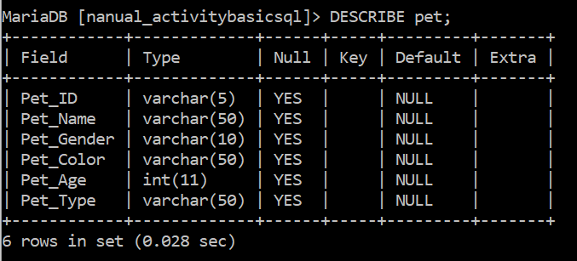

1. In case you want to change the name of your table, you can always change it using the command below:

To rename the table, you should use: **Rename table, To** statements.

**Syntax: RENAME TABLE** tb1 **TO** tb2;

**Example: *Rename TABLE pet to pet_shop;***

Now, try it renaming your table to ***tbl_pet.***

**My command prompt:**

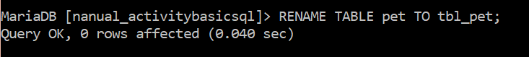

1. Create a table **“Owner”.** Your owner table should have the following fields: Owner_ID, Owner_Name, ***Own***_Address, Owner_***Ginger***.

***Your table should be:***

|  |  |  |  |
| --- | --- | --- | --- |
| **Owner_ID** | **Owner_Name** | **Own_Address** | **Owner_Ginger** |

**My command prompt:**



1. Rename table ***owner to tbl_owner.***

**My command prompt:**

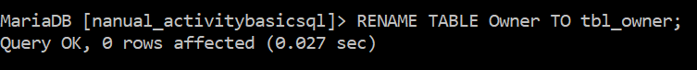

1. Add new table **tbl_Buyer** with the following specifications:

|  |  |  |  |
| --- | --- | --- | --- |
| **Buyer_ID** | **Buyer_Name** | **Buyer_Address** | **Buyer_Gender** |

**My command prompt:**

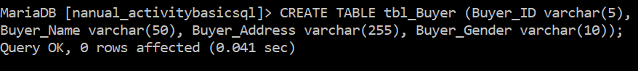

1. Using your tbl_pet table, add the following fields: ***Pet_Breed, Pet_Price, Pet_contact, Pet_address.***

***Hint****: Use the keyword* ***Alter*.**

The **SQL ALTER TABLE** statement is used to add, modify, or drop/delete columns in a table.

The **SQL ALTER TABLE** statement is also used to rename a table.

**Syntax:** To add a column\fields in a table, the SQL ALTER TABLE syntax is:

***ALTER TABLE table_name ADD column_name column_definition;***

**Example: *ALTER TABLE tbl_pet add pet_address varchar (30);***

Let's look at SQL ALTER TABLE example that adds more than one column\fields.

***ALTER TABLE tbl_pet ADD (pet_address varchar(50), pet_age int(2));***

***Your table tbl_pet should have the following fields:***

|  |  |  |  |  |  |  |  |  |  |
| --- | --- | --- | --- | --- | --- | --- | --- | --- | --- |
| **Pet_ID** | **Pet_Name** | **Pet_Gender** | **Pet_Color** | **Pet_Age** | **Pet_Type** | **Pet_Breed** | **Pet_Price** | **Pet_contact** | **Pet_address** |

**My command prompt:**

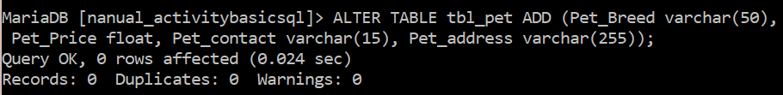

1. Add 1 new column or fields for tbl_owner : **Owner_Contact.**

**Hint: Use Alter, Add.**

***Your table should be***

|  |  |  |  |  |
| --- | --- | --- | --- | --- |
| **Owner_ID** | **Owner_Name** | **Own_Address** | **Owner_Ginger** | **Owner_Contact** |

**My command prompt:**

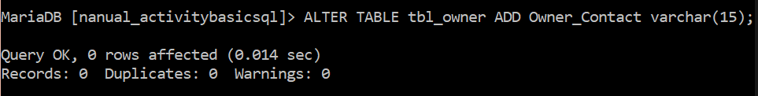

1. Rename the columns or fields ***own_address to owner_address, then owner_ginger to owner_gender*** of tbl_owner***.***

**RENAME COLUMN IN TABLE**

To rename a column in an existing table, the SQL ALTER TABLE syntax is:

***ALTER TABLE table_name CHANGE COLUMN old_name new_name datatype;***

**Example:**

***ALTER TABLE tbl_owner CHANGE COLUMN own_address owner_address VARCHAR(100);***

***Your table should be***

|  |  |  |  |  |
| --- | --- | --- | --- | --- |
| **Owner_ID** | **Owner_Name** | **Owner_Address** | **Owner_Ginger** | **Owner_Contact** |

***Now, try changing for owner_ginger to owner_gender.***

**My command prompt:**

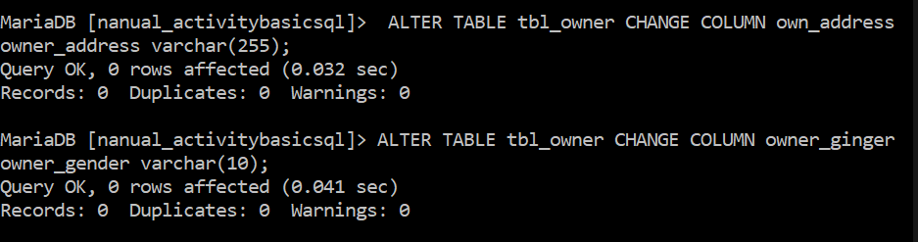

1. Remove the column ***pet_contact and pet_address from tbl_pet***.

**Hint: Alter, Drop**

**DROP COLUMN IN TABLE**

To drop a column in an existing table, the SQL ALTER TABLE syntax is:

***ALTER TABLE table_name DROP COLUMN column_name;***

***Example:***

***ALTER TABLE tbl_pet DROP COLUMN pet_address;***

***Now, try removing pet_contact***

**My command prompt:**

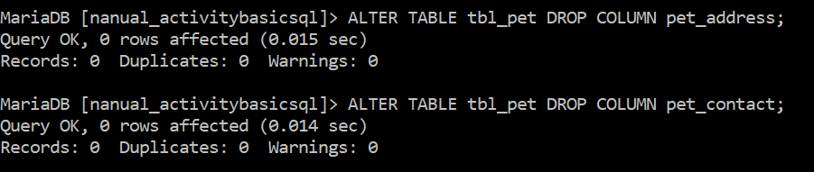

1. Drop/Remove the table **“tbl_buyer”.**

**My command prompt:**

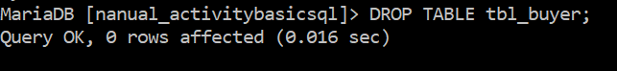

***---------------------- [DML-Records Manipulation] ----------------------***

***INSERT STATEMENT is used to insert a single record or multiple records into a table in MySQL.***

**SYNTAX**

In its simplest form, the syntax for the INSERT statement when inserting a single record using the VALUES keyword in MySQL is:

*INSERT INTO table (column1, column2, ... )*

*VALUES (expression1, expression2, ... ), (expression1, expression2, ... ),...;*

***Example:***

* 1. If you have the following table definition, here’s how you do it.

|  |  |  |  |
| --- | --- | --- | --- |
| Pet_id | Pet_name | Pet_gender | Pet_age |

***Insert into tbl_pet values (1, ‘Nymeria’,’female’, 5);***

***Your table would become:***

|  |  |  |  |
| --- | --- | --- | --- |
| Pet_id | Pet_name | Pet_gender | Pet_age |
| ***1*** | ***Nymeria*** | ***female*** | ***5*** |

**My command prompt:**

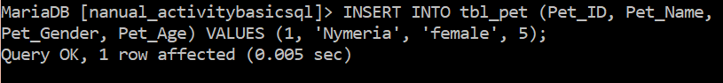

* 1. By using SELECT command, you are able to display the records containing in the **tbl_pet** table. As you wish, invoke the following statement:

***SELECT *from tbl_pet;***

**My command prompt:**

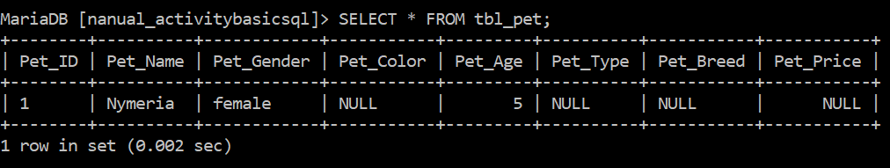

* 1. What if you want to insert 2 or more than rows or records? Here’s how.

***Insert into tbl_pet values (2, ‘Lee Tsu Non’,’male’, 15), (3, ‘Kelly Cally’,’female’, 16);***

***Your table would become:***

|  |  |  |  |
| --- | --- | --- | --- |
| Pet_id | Pet_name | Pet_gender | Pet_age |
| 1 | Nymeria | female | 5 |
| ***2*** | ***Lee Tsu Non*** | ***male*** | ***15*** |
| ***3*** | ***Kelly Cally*** | ***female*** | ***16*** |

**My command prompt:**

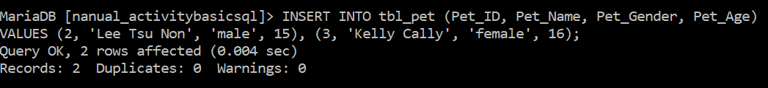

*Or if you want to store only specific value or fields to your table, you do this:*

***Insert into tbl_pet (pet_id, pet_name, pet_age) values (2, ‘Anne ann’, 12);***

***Your table would have additional information about Anne:***

|  |  |  |  |
| --- | --- | --- | --- |
| Pet_id | Pet_name | Pet_gender | Pet_age |
| ***2*** | ***Anne ann*** |  | ***12*** |

**My command prompt:**

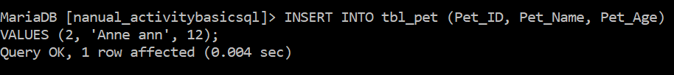

* 1. Using your **tbl_pet** table, store these values as an additional record:

|  |  |  |  |
| --- | --- | --- | --- |
| Pet_ID | Pet_Name | Owner_Gender | Pet_Age |
| 1 | Amenadiel | Female | 5 |
| 4 | Lucifer Morningstar | Male | 4 |

**My command prompt:**

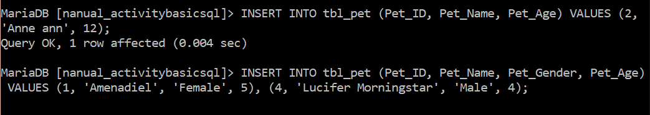

*Now, show the records of your* ***tbl_pet*** *table using* ***SELECT*** *command.*

**My command prompt:**

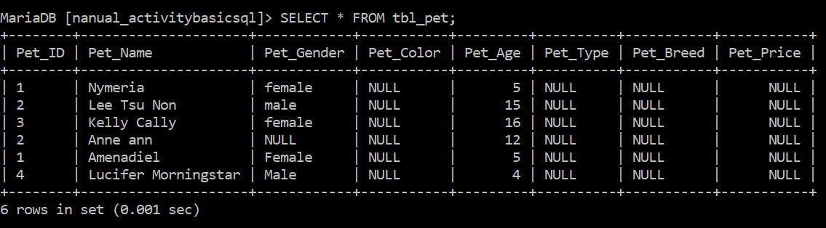

* 1. You just tried removing **tbl_buyer** table earlier using **DROP** command. This time I want you to use

**NOTE:** There are no words after the word “use”. Thus, I left the item as is.

1. Using your **tbl_owner** table, store these values: ***1,” Cain”, “Davao City”, “female”, 2229614.***

***Your table should become:***

**NOTE:** There are no words or objects after “become:”

**My command prompt:**



1. Show records of your **tbl_owner** table using **select** statement. Invoke the SQL statement below to accomplish the task:

***SELECT *from tbl_owner;***

You should have shown like this:

|  |  |  |  |  |
| --- | --- | --- | --- | --- |
| ***Owner_ID*** | ***Owner_Name*** | ***Owner_Address*** | ***Owner_Gender*** | ***Owner_Contact*** |
| ***1*** | ***Cain*** | ***Davao City*** | ***Female*** | ***2229614*** |

**My command prompt:**

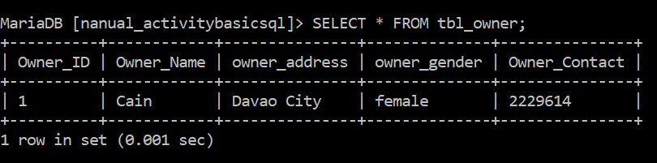

1. Using the **tbl_pet** table, store these information (sequence):

***1, “Anna”, “Female”, “Pinkish White”, 12,’Dog’,”Husky”,*** ***2300.45***. ***(Show your records after)***

Your table should have become:

|  |  |  |  |  |  |  |  |
| --- | --- | --- | --- | --- | --- | --- | --- |
| Pet_ID | Pet_Name | Pet_Gender | Pet_Color | Pet_Age | Pet_Type | Pet_Breed | Pet_Price |
| 1 | Anna | female | Pinkish White | 12 | Dog | Husky | 8900.00 |

**NOTE:** The Pet_Price values in the instruction and in the table do not match. (Instruction says 2300.45 while the table says 8900.00. I went with what is being asked in the instruction.

**My command prompt:**

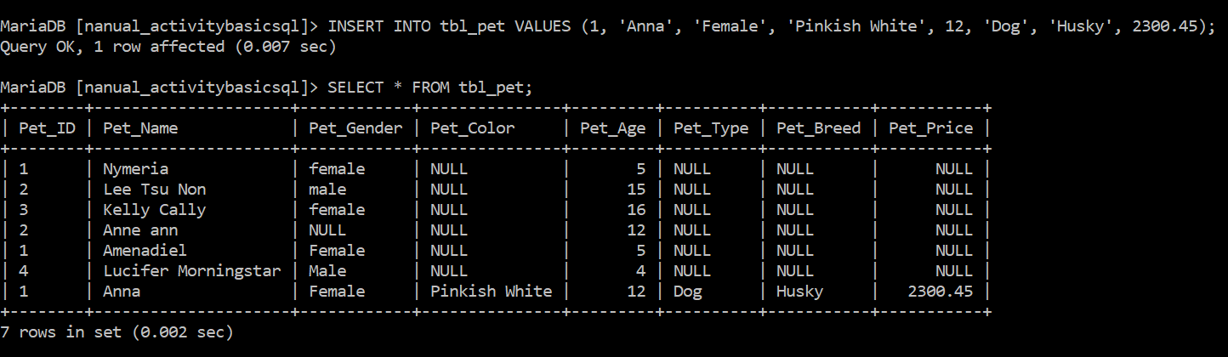

1. Insert information for **tbl_pet** atleast 5 of your own specifications and preference.

**My command prompt:**

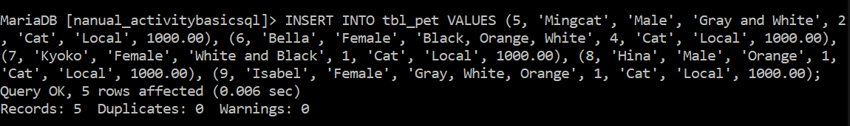

1. Insert the following information to your **tbl_pet**:

**NOTE:** I am unsure what information I’m supposed to add to tbl_pet. If it is the information in the table below, they have already been added to the table in the previous instructions.

(***Look at the table below carefully of what columns or fields are used upon storing values.***)

|  |  |  |  |
| --- | --- | --- | --- |
| Pet_id | Pet_name | Pet_gender | Pet_age |
| 1 | Nymeria | female | 5 |
| 2 | Lee Tsu Non | male | 15 |
| 3 | Kelly Cally | female | 16 |
| ***4*** | ***Anne ann*** |  | ***12*** |

***NOTE: Observe that you are able to store information of pet having the same Pet_id since it wasn’t specified as primary key. Hence, duplication is possible.***

1. Display all fields from the table **tbl_pet.**

**My command prompt:**

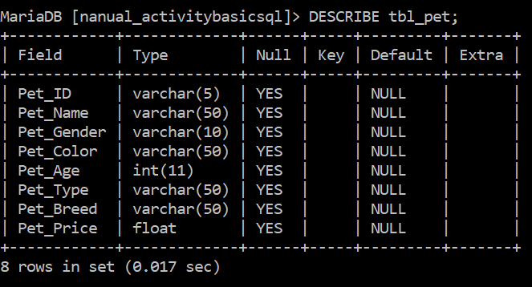

1. Show records of your **tbl_pet.**

**My command prompt:**

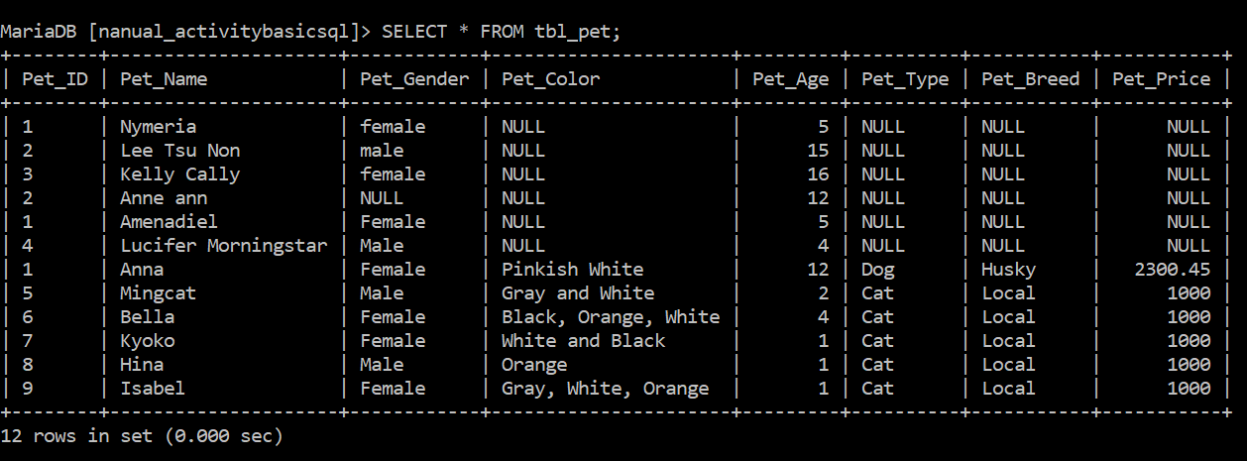

1. Insert information to your table **tbl_owner** atleast 3 of your own specifications and preference.

**My command prompt:**

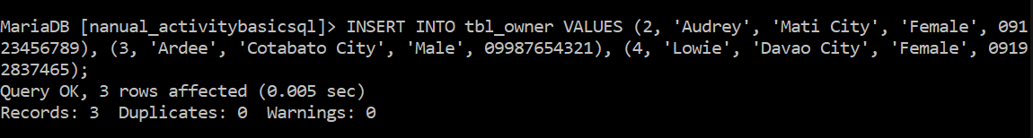

1. Show records of your **tbl_owner.**

**My command prompt:**

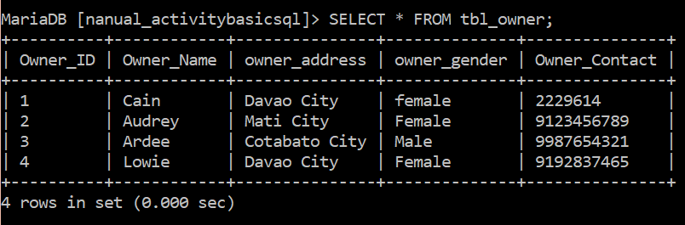

1. Display data dictionary of **tbl_owner and tbl_pet.**

**My command prompt:**

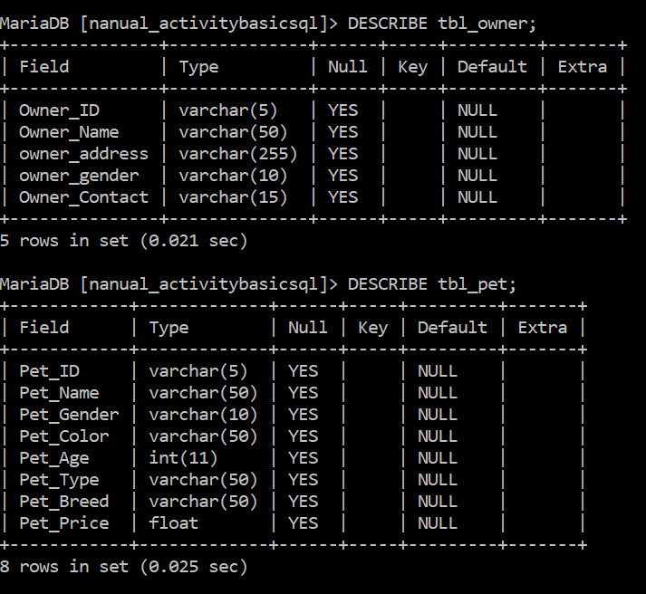

1. Remove the table **tbl_owner.**

**Hint: Use drop command.**

**My command prompt:**

